Instructions for git

What is git?

Version control systems are a category of software tools that help a software team manage changes to source code over time. Git is the most commonly used type of version control system

Main functions of git relevant to us:

1. The git workflow enables us to organize collaborative coding projects stored in a git repository like Bitbucket or Github.

* We can track all changes made to the code at any point in time

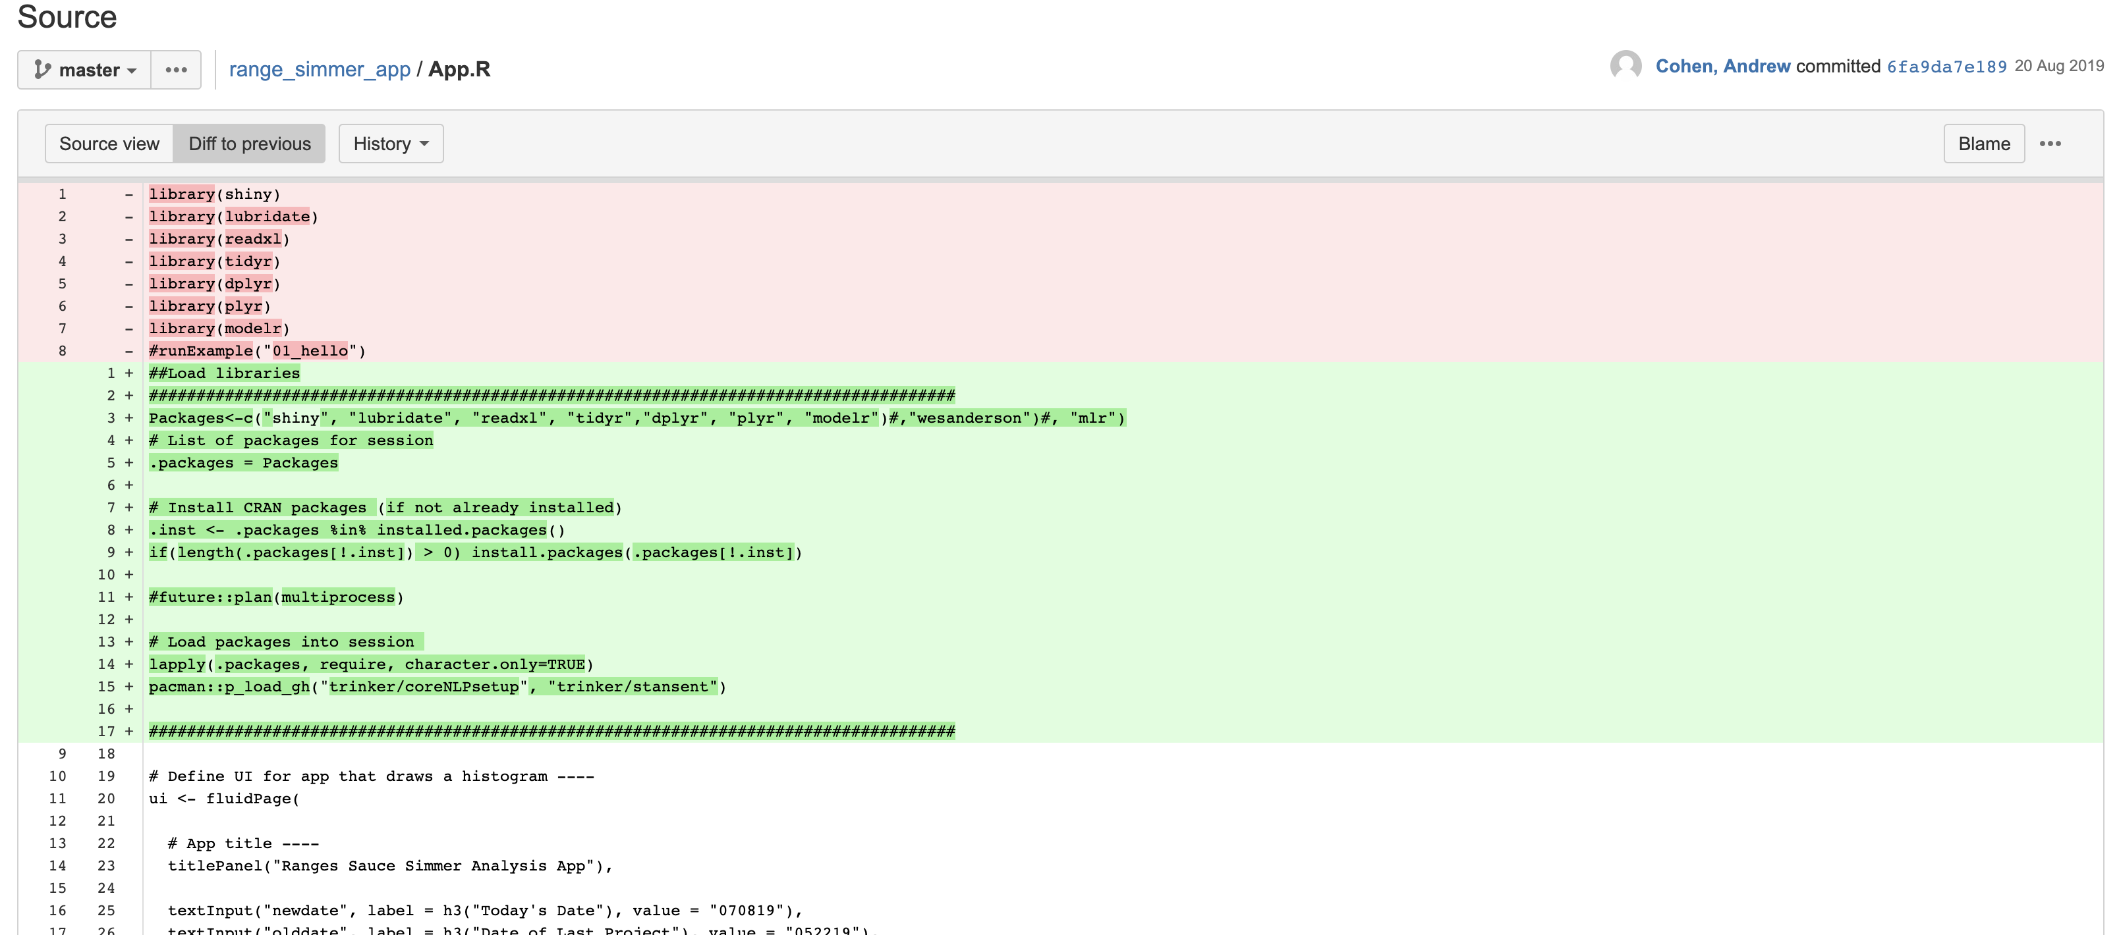

* The leader of each project must approve all changes to the code. This ensures that no changes are made to someone else’s code project leader seeing

1. The source code for any web application is launched either on a local server or a webserver which is an entirely separate

Git is what allows us to communicate with this server.

1. Download and Install git:

* Download git for windows here: <https://gitforwindows.org/>
* Open the file and install git for windows (default options worked fine for me)
* For more info click here: <https://www.atlassian.com/git/tutorials/install-git#windows>

1. Configure git

* Open Command Prompt
* Run the following command lines

1. Git Clone: Connect a local folder to your online repository.

* Navigate into your bitbucket repository and copy the following link (Note that a new folder will be created under the folder that you navigate to. It is wise to navigate to the folder that you want your repo clone to live in).



* Enter the following command into the command prompt
* You should now have a see a folder that shares the name of your repository
* If you are cloning an existing repository, the files in the repo should now show up in the folder that was created on your local machine (for cloning new repos see “Git Push”).

1. Git Push: Push saved changes to code from your local machine to repository.

Note: If you are initializing a new repository, once you have created the folder, you should then drop all files that you want to exist on the repository into the local folder you created and continue the following steps.

* Enter the following commands to add your files to the existing repository.

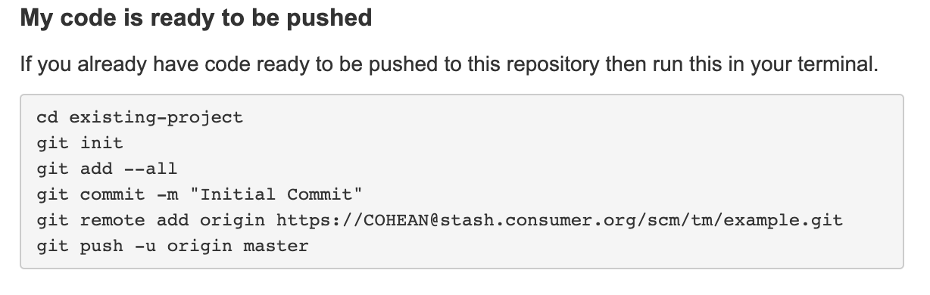

Note that for chaning changing one file

1. Git Pull: If a change is made to your repository and you want to update your local files

* Navigate to the existing project in your command prompt
* Enter the following code
  + git pull